
Case study – Exhibition Stand. IBC Amsterdam

Brief – Provide various design concept options for modular exhibition stand with central hospitality area, PC equipment storage and benching. Signage and display for three associate companies.

Scheme Design – The layout was required to have central facilities area to be accessed by all three companies, graphic and product display space was at a premium with viewing impact critical. The construction utilised an existing office mobile desk and screen system adapted to different configurations to provide a mix of open display and semi- private meeting areas. The light weight modular construction and durable finishes proved to be ideal for low cost transportation and fast erection and dismantling.

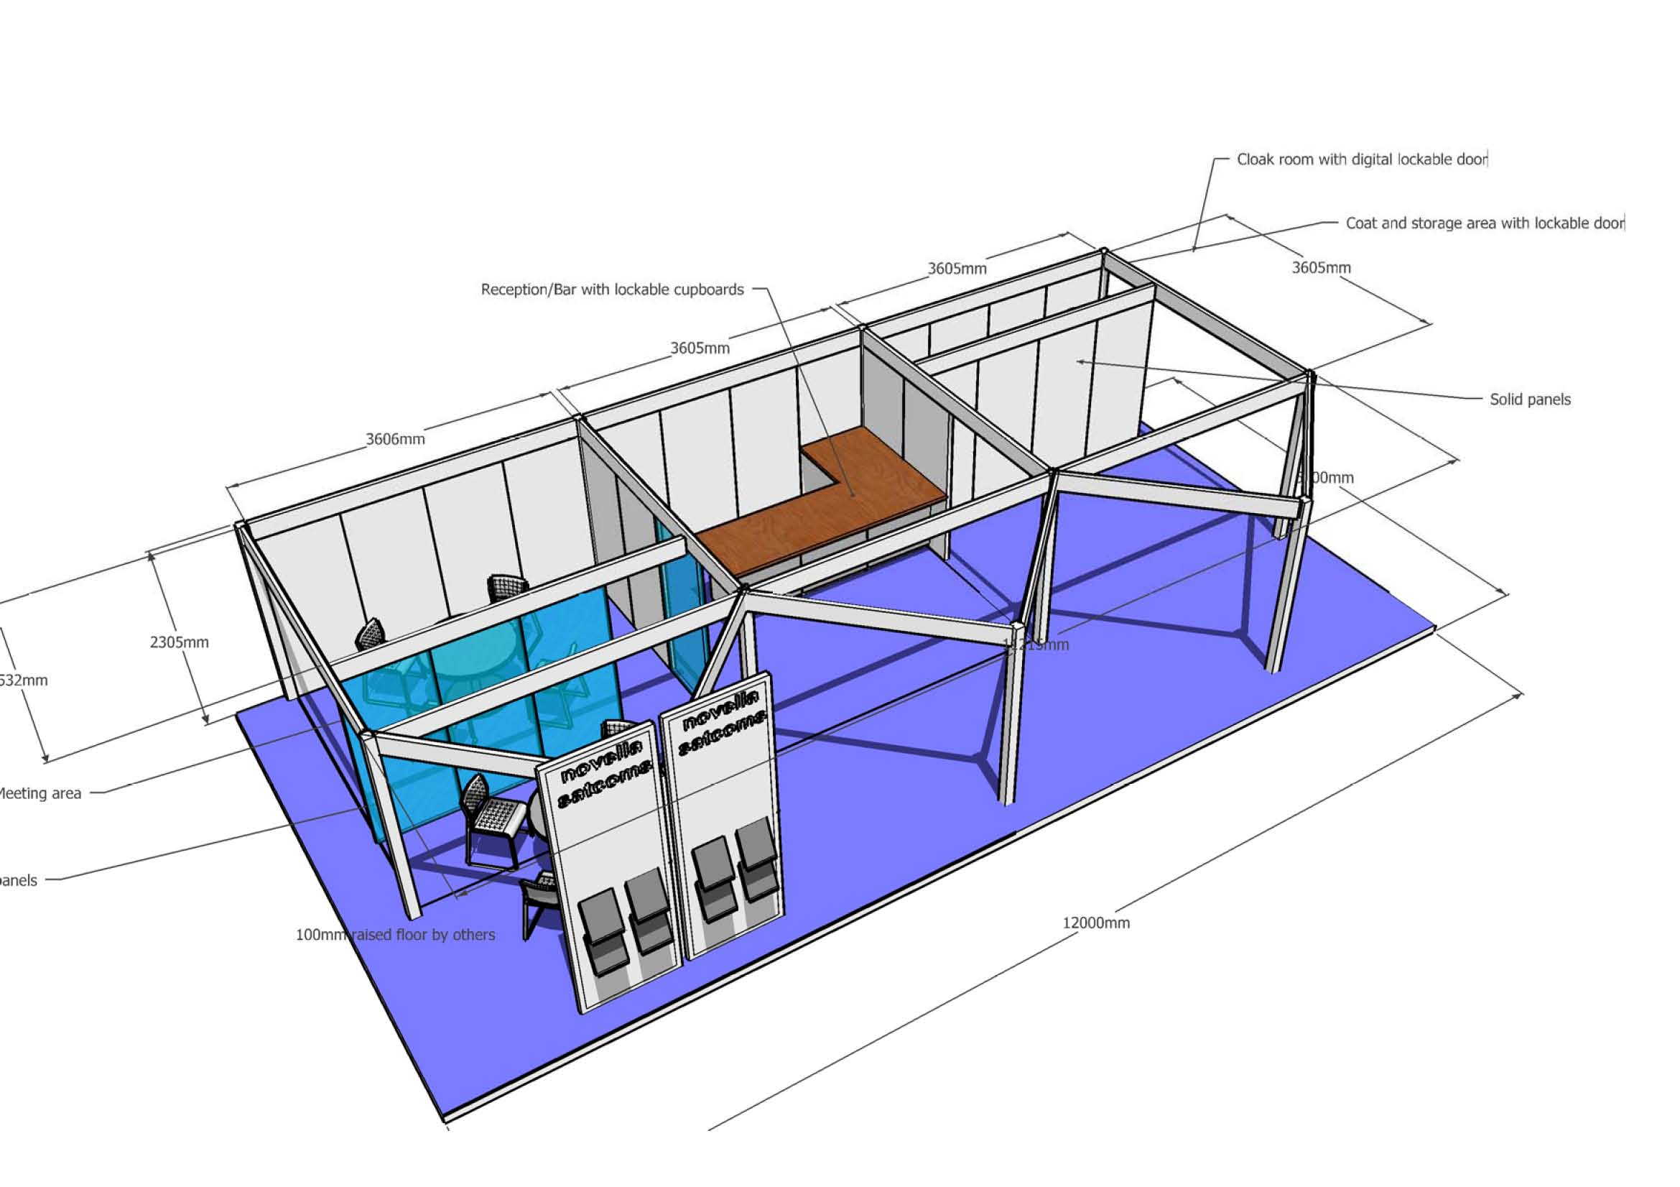

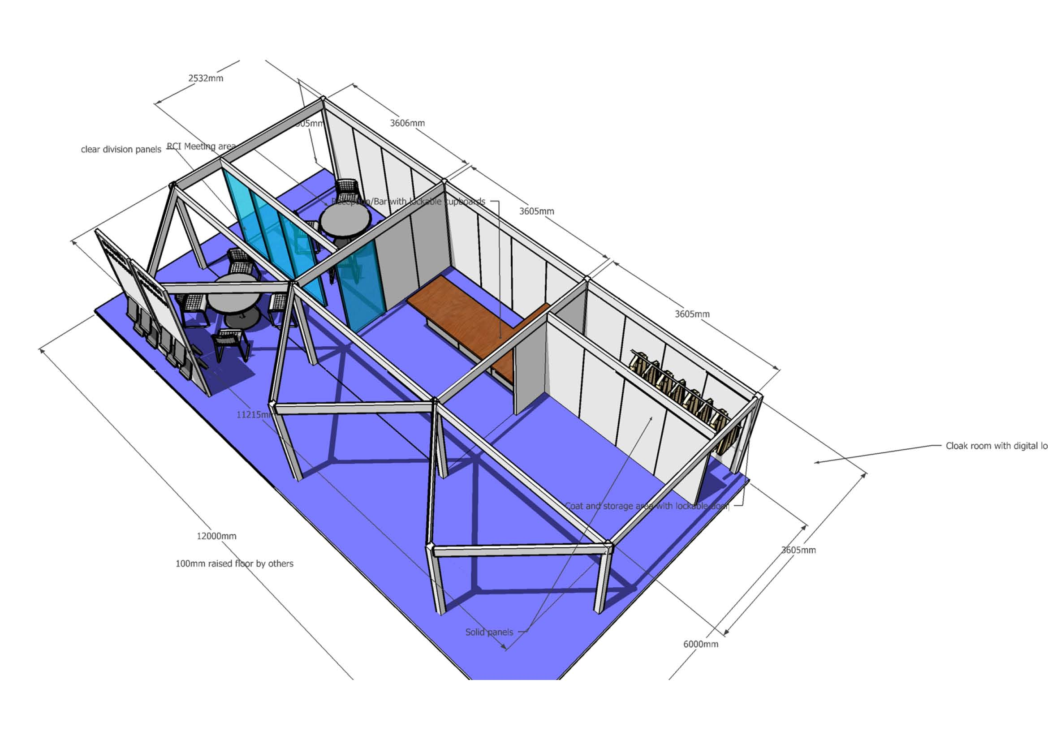

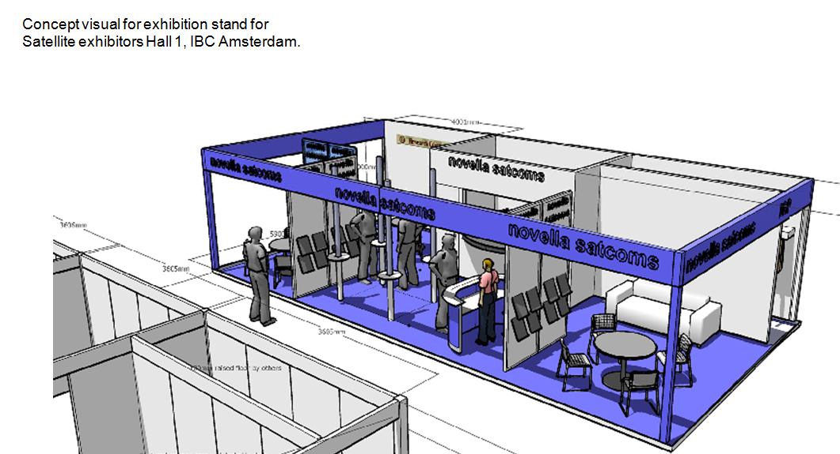
Spacedesigneurope
M : +44 [ 0]7710 402 457
Email: john@spacedesigneurope.co.uk
www.spacedesigneurope.co.uk

M : +44 [ 0]7710 402 457
Email: john@spicehop.com
www.spacedesignfrance.co.uk

